**ROECLIFE & WESTWICK PARISH COUNCIL**



**NEIGHBOURHOOD DEVELOPMENT PLAN**

*REGULATION 14 CONSULTATION SUMMARY*

*AND QUESTIONNAIRE*

*15th April 2019*

**This is your opportunity to comment on our draft Neighbourhood Development Plan. Please take a few minutes to read this summary and complete the questionnaire. Download further copies online at** [www.roecliffewestwickvillage.co.uk](http://www.roecliffewestwickvillage.co.uk/) **(where the full draft of the Plan may also be viewed). Please return your completed questionnaires by 28th. June 2019 to Holmeside Farm, Roecliffe, YO51 9LY. Hard copies of the full Plan are available to view at Boroughbridge Library, Telephone kiosk Library, Village noticeboards and the Church. All responses are strictly confidential. Every member of your household may return a questionnaire, which will be analysed to enable us to modify our draft Plan before we submit it to Harrogate Borough Council.**

**If you require any assistance please call Dave Siswick on 01423 325290.**

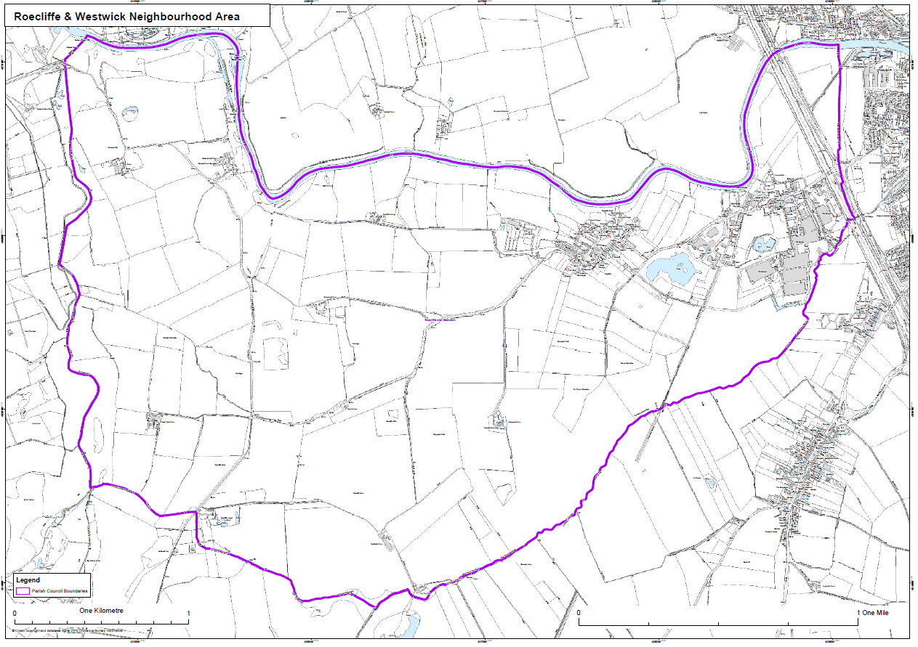

**Roecliffe and Westwick parish map**

**Your name (optional)…………………………………………………………. Post code…………………………….**

**The vision – this is how we want to see our parish develop over the next 15 years.**

*1. “The distinctive character and appearance of Roecliffe & Westwick shall be preserved and enhanced, with particular reference to the Conservation Area and the defined Development Limits by ensuring positive management of future developments and avoiding high density housing. A safer and more secure environment will be developed, particularly as regards highways, so that Roecliffe & Westwick continues to be a safe and peaceful rural community. Existing green space, footpaths and bridleways will be protected and preserved, to improve the quality of life for all people who live and work in Roecliffe & Westwick but also to enhance the visual appearance of the area and for the benefit of visitors. To continue building a stronger community spirit and greater cohesion, local residents will continue to be consulted and involved in delivery of all aspects of the Plan.”*

**Do you agree with the Vision?** Yes ⭘ No ⭘ Don’t know ⭘ (please tick as appropriate)

2. Please add any comments you have about the vision

Comments:

**Key objectives – these are what we will seek to ensure in order to make the Vision a reality.**

3. To ensure sensitive development that protects and enriches the landscape and built setting throughout the Neighbourhood Area.

**Do you agree with this objective?** Yes ⭘ No ⭘ Don’t know ⭘

4. To ensure that any housing development is tailored to the future needs of Roecliffe & Westwick residents.

**Do you agree with this objective?** Yes ⭘ No ⭘ Don’t know ⭘

5. To protect the landscape generally including agricultural land, woodland, wildlife habitats, the historic sites and particularly the key views into and out of the Conservation Area.

**Do you agree with this objective?** Yes ⭘ No ⭘ Don’t know ⭘

6. To protect the valuable green spaces within Roecliffe & Westwick.

**Do you agree with this objective?** Yes ⭘ No ⭘ Don’t know ⭘

7. To improve the existing footpath network by creating new footpaths and cycle ways to extend connectivity and improve access to the surrounding rural countryside.

**Do you agree with this objective?** Yes ⭘ No ⭘ Don’t know ⭘

8. To ensure all the ‘village assets’ are protected.

**Do you agree with this objective?** Yes ⭘ No ⭘ Don’t know ⭘

9. To support and strengthen the small number of local businesses and assist those working from home.

**Do you agree with this objective?** Yes ⭘ No ⭘ Don’t know ⭘

10. To support residents on an ongoing basis in the delivery and monitoring of the Plan.

**Do you agree with this objective?** Yes ⭘ No ⭘ Don’t know ⭘

11. To seek on-going improvements to highways and develop a safer route for pedestrians passing through Roecliffe.

**Do you agree with this objective?** Yes ⭘ No ⭘ Don’t know ⭘

12. Please add any comments you have about the objectives

Comments:

**The draft policies – these are the detailed planning policies against which future development proposals will be assessed, alongside other Borough-wide policies contained in the Harrogate Local Plan.**

13. **Policy A1: Design and Development**

New development proposals should demonstrate that they preserve and enhance the distinct rural feel of the village of Roecliffe and its surrounding rural environment by:

• Respecting the local character, historic and natural assets of the surrounding area, in particular the Conservation Area, and taking every opportunity, through design and materials, to reinforce local distinctiveness and a strong sense of place.

• Ensuring that developments outside the Conservation Area do not adversely affect the character and appearance of the Conservation Area.

• Maintaining space and proportion of building plots.

• Ensuring that new structures do not dominate the village streetscape.

• Incorporating landscaping to mitigate the impact of development. Planting programmes for new development should incorporate native arboreal species local to the area.

• Prohibiting the removal of any trees that have a significant amenity value, without the support of an arboriculture report by a reputable company.

• Using traditional bricks and pantiles as the dominant construction material for new buildings and boundary walls.

• Maintaining the consistent two-storey eaves height found throughout the Conservation Area.

• Continuing to use rural and vernacular detailing on new build structures to ensure that the rural and historic character is retained.

• Providing pitched roofs and regularly spaced windows that do not dominate the street scene.

• Ensuring proposals for external lighting which require planning permission demonstrate how they respect local character, residential amenity and biodiversity.

**Do you agree with the policy?** Yes ⭘ No ⭘ Don’t know ⭘

Comments:

14. **Policy A2: Design of Extensions**

In addition to the requirements of Policy A1 the following shall apply to the design of extensions where planning permission is required:

• Extensions, including garages, should not cause the property to dominate its neighbourhood and street scene, and space will be retained between buildings and the street similar to the space between neighbouring properties.

• Extensions will be in materials to complement the existing or neighbouring houses.

• Original character features should be retained and replicated in the extension.

• Dormer windows shall be avoided on front elevations. They should be set back from the eaves, side/party walls and set down

from ridgelines.

• Door architraves, window styles and frames should closely reflect the style of the original building.

**Do you agree with the policy?** Yes ⭘ No ⭘ Don’t know ⭘

Comments:

15. **Policy A3: Community Involvement**

Planning applications for ten or more new dwellings shall be accompanied by a Statement of Community Involvement. This statement should include:

• An explanation of how the community has been consulted about the proposals;

• A demonstration that a range of means has been used to engage with local people;

• A record of the views expressed by local people;

* An explanation of how the proposals have responded to local people’s views;

Any subsequent application will only be supported if it is clear the feedback from the community has been taken into account as far as practicable.

**Do you agree with the policy?** Yes ⭘ No ⭘ Don’t know ⭘

Comments:

16. **Policy A4: Key Views**

Development should consider the visual impact of proposals and ensure careful design to protect the following key views, (also identified on the policies map), in order to maintain the character and appearance of the parish of Roecliffe and Westwick.

* Key View 1 - of Roecliffe village when entering along Bar Lane from the east, with the backs of houses visible across small fields and paddocks.

• Key View 2 - from the footpath to the north-west across the fields from which views of Roecliffe village, church and Old Vicarage can be obtained.

• Key View 3 - from Bar Lane and Thorns Lane where a distant view of the houses and gardens can be seen beyond the small hedged tofts stretching to Thorns Lane.

• Key View 4 - from the footpath to the north west of Roecliffe village where views back to the Parish Church can be had.

• Key View 5 **-** the approach to the village is contained to the east by woodland. This contained entrance via narrow lanes between walls, hedges and woodland give way to the unexpected open vista of The Green.

• Key View 6 **-** the approach to the village is contained to the west by woodland at The Common and the water-filled clay pits at the former brick works. This contained entrance via a narrow lane between walls, hedges and woodland give way to the unexpected open vista of The Green, beyond the Crown Inn.

**Do you agree with the policy?** Yes ⭘ No ⭘ Don’t know ⭘

Comments:

17. **Policy B1: Small Scale Housing Development**

Development proposals will be welcomed where these:

a) Are small-scale (i.e. less than 10 dwellings);

b) Do not extend the village into the surrounding countryside outside the village of Roecliffe Development Limits (2016).

**Do you agree with the policy?** Yes ⭘ No ⭘ Don’t know ⭘

Comments:

18. **Policy B2: Development Criteria Highways**

Where appropriate, measures which enhance traffic management and the operation of the highways will be encouraged where such can be shown to have a positive impact upon highway safety in and around Roecliffe village. Any measure should be of a design appropriate to the character of the village.

**Do you agree with the policy?** Yes ⭘ No ⭘ Don’t know ⭘

Comments:

19. **Policy B3: Adequate Car-Parking Provision**

Residential car-parking in any new housing development should provide off-road car parking spaces in accordance with standards as set out by North Yorkshire County Council as a minimum. Development proposals must demonstrate that there will be no over-spill of residential car-parking onto Main Street, Roecliffe.

**Do you agree with the policy?** Yes ⭘ No ⭘ Don’t know ⭘

Comments:

20. **Policy C1: Maintaining Village Facilities and Services**

The change of use of the following facilities will only be permitted if it can be demonstrated that reasonable efforts have been made to secure their continued use for the current purposes and/or alternative provision is made:

• Roecliffe C of E Primary School

• St. Mary’s Church, Roecliffe, and the churchyard

• Crown Inn

**Do you agree with the policy?** Yes ⭘ No ⭘ Don’t know ⭘

Comments:

21. **Policy C2: Non Designated Local Heritage Assets**

Non designated local heritage assets will be conserved and enhanced, wherever possible for their historic significance and/or their importance to local distinctiveness, character and sense of place.

Proposals for development that affect such assets should take full and proper account of the scale and impact of any harm or loss to the community.

The following non designated local heritage assets have been identified:

*The Roecliffe “Best Kept Village” sign, Victorian “VR” Letter Box, The Old Vicarage, Roecliffe, Ivy Farm, The Old Methodist Chapel, Telephone Kiosk, two war graves, Manor House.*

This list is subject to change if local heritage assets are identified in the future.

**Do you agree with the policy?** Yes ⭘ No ⭘ Don’t know ⭘

Comments:

22. **Policy D1: Footpaths, Cycleways and Bridleways**

Development proposals will take all reasonable opportunities to improve footpath and bridleway access, by, for example, facilitating new circular walks and new safer alternatives to existing routes. Any proposed routes and changes to existing routes will be expected to take advantage of features such as good views, amenity areas and also provide further planting as part of the proposals.

The layout of any proposed development should take into consideration the possibility of future footpaths and bridleways and access links not directly provided by the developments.

**Do you agree with the policy?** Yes ⭘ No ⭘ Don’t know ⭘

Comments:

23. **Policy E1: Local Green Space**

In accordance with national policy on Green Belts the following areas are designated as Local Green Spaces where new development will only be allowed in very special circumstances:

• LGS1: The village green • LGS2: Roecliffe Common

**Do you agree with the policy?** Yes ⭘ No ⭘ Don’t know ⭘

Comments:

24. **Policy E2: Green Infrastructure**

The following identified green corridors will be improved and protected for the multiple benefits derived from them for the community, including habitats preservation, flood risk mitigation, noise reduction, wildlife movement, health and recreational opportunities. Development proposals should not result in the disruption of the functioning of these corridors:

• River Ure Corridor

• Tutt and Bishop Monkton Corridor

• Holbeck valley Bottom Corridor

• Knaresborough to Boroughbridge dismantled railway corridor

• River Tutt diversion screen

• Bar Lane Green Gap

Development proposals within or adjacent to these corridors should seek to integrate strong green infrastructure, including:

• New accessible public green spaces for formal and informal recreation. New green space should seek to address identified deficits in the area and/or vicinity of the development.

• Retention of hedges, trees and landscape features.

• Retention of existing street trees and those ‘off street’ which form part of the street scene and provision of new trees wherever practicable. Existing trees in the street scene should be conserved and replaced on a like for like basis should felling be deemed inevitable.

• Provision of porous surfaces wherever hardstanding is required off the carriageway.

• Provide corridors for wildlife to move through, around or across a development site.

**Do you agree with the policy?** Yes ⭘ No ⭘ Don’t know ⭘

Comments:

25. **Policy F1: Local Business Support**

Development proposals which provide support and give encouragement to local businesses and ensure viability is maintained and strengthened will be supported provided that they:

a) Contribute to the character and vitality of the local area.

b) Protect residential amenity

c) Do not adversely impact upon road safety.

**Do you agree with the policy?** Yes ⭘ No ⭘ Don’t know ⭘

Comments:

26. **Policy F2: Broadband/Connectivity**

To support more people working from home and to encourage local micro/small business growth, this Plan supports the technology infrastructure that serves to improve broadband speed throughout the Neighbourhood Area.

Development proposals should demonstrate how they will contribute to and be compatible with internet connectivity. This should include plans showing suitable infrastructure provision to ensure all new developments are ‘fibre-ready’.

**Do you agree with the policy?** Yes ⭘ No ⭘ Don’t know ⭘

Comments:

27. **Policy F3: Bar Lane Industrial Zone**

The area around the current Bar Lane Industrial Estate, as marked on the policies map, is

designated an Industrial Zone. Business development schemes within this zone are encouraged provided that:

• new buildings and structures are in keeping with its surroundings in terms of scale and design.

• adequate car-parking provision for on-site staff, commercial vehicles and visitors to the extent that there will be no over-spill onto the highway, except in exceptional circumstances.

**Do you agree with the policy?** Yes ⭘ No ⭘ Don’t know ⭘

Comments:

**Thank you! We will keep you informed of progress via our website,** [www.roecliffewestwickvillage.co.uk](http://www.roecliffewestwickvillage.co.uk/)